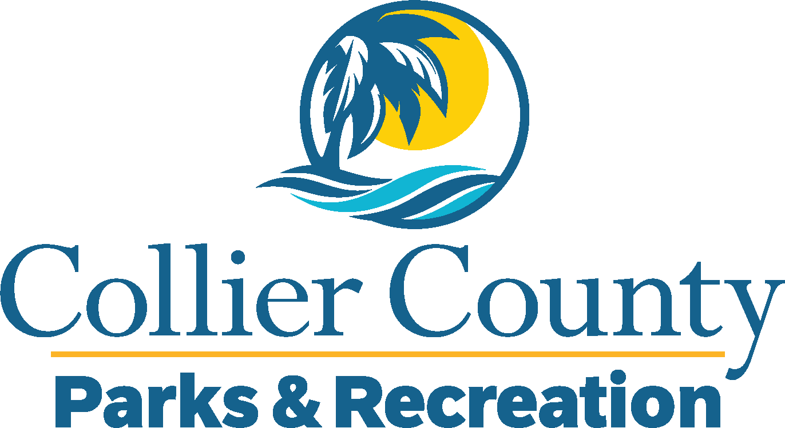
Parks & Recreation Advisory Board

meeting agenda
LOCATION: | North Collier Regional Park
Date: | Wednesday, November 20, 2024
ADDRESS: | 15000 Livingston Road Naples, FL 34109
Time: | 2:00 PM
- Call to order
  - Welcome by the Director
  - Roll Call
  - Verification of Quorum
- Pledge of Allegiance and Invocation
- Approval of the Agenda
- Approval of Previous Meeting Minutes
- New Business
  - Introduction to New Leadership
  - Hurricane Update
  - Pickleball Fees Increase Recommendation
- OLD BUSINESS
  - Pelican Bay Foundation Pickleball Update
  - East Naples Community Park Pickleball Update
- Public comments
- Director’s Report
- Adjournment

