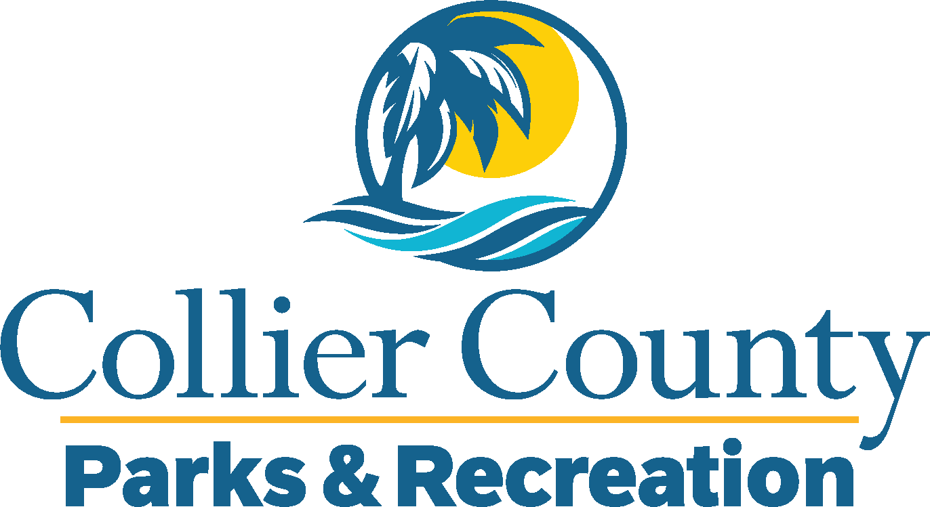
Parks & Recreation Advisory Board

meeting agenda
LOCATION: | Immokalee Community Park
Date: | Wednesday, February 19, 2025
ADDRESS: | 321 N 1st St, Immokalee, FL 34142
Time: | 6:00 PM
- Call to order
  - Welcome by the Director
  - Roll Call
  - Verification of Quorum
- Pledge of Allegiance and Invocation
- Approval of the Agenda
- Approval of Previous Meeting Minutes
- New Business
  - Immokalee Community Park Presentation
  - Immokalee Community Park/ Immokalee High School
- OLD BUSINESS
  - Immokalee Sports Complex - Update
- Board / Public comments
- Manager Updates
- Director’s Report
- Adjournment

