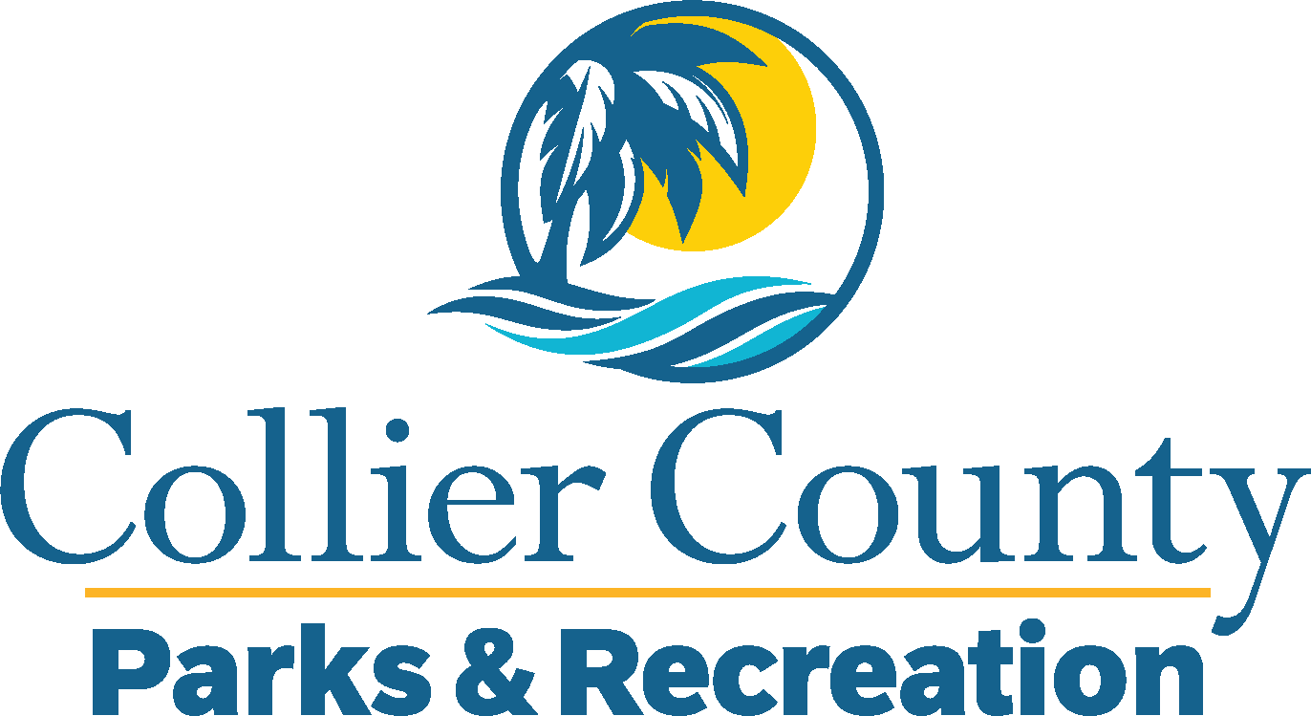
Parks & Recreation Advisory Board

meeting agenda
LOCATION: | Growth Management Department
Date: | Wednesday, January 15, 2025
ADDRESS: | 2800 Horseshoe Drive N. Naples, FL 34104
Time: | 2:00 PM
- Call to order
  - Welcome by the Director
  - Roll Call
  - Verification of Quorum
- Pledge of Allegiance and Invocation
- Approval of the Agenda
- Approval of Previous Meeting Minutes
- New Business
  - 2025 PARAB Schedule
  - Growth Management Overview
  - Beach Umbrella Safety
- OLD BUSINESS
  - Advisory Board Attendance
  - East Naples Community Park Pickleball Update
  - 311 (March)
- Board / Public comments
- Manager Updates
- Director’s Report
- Adjournment

